NAME: S. DHARANI
REG NO:192472364
COURSE CODE: DSA0401
NUMPY ANALYSIS – QUESTIONS AND ANSWERS
QUESTION 3: AVERAGE SALE PRICE OF HOUSES
AIM:
To calculate the average sale price of houses with more than four bedrooms using NumPy arrays.
ALGORITHM:
- Import the NumPy library.
- Create an array containing the number of bedrooms, square footage, and sale price of each house.
- Select houses with more than four bedrooms using a condition.
- Extract the sale prices of the selected houses.
- Calculate the average sale price using np.mean().
- Display the result.
CODE:
import numpy as np
Columns: Bedrooms, Square Footage, Sale Price
house_data = np.array([
[3, 1200, 200000],
[5, 2000, 350000],
[4, 1500, 250000],
[6, 2500, 450000],
[5, 2200, 400000]
])
filtered_houses = house_data[house_data[:, 0] > 4]
average_price = np.mean(filtered_houses[:, 2])
print("Average sale price:", average_price)
INPUT:
[[3, 1200, 200000],
[5, 2000, 350000],
[4, 1500, 250000],
[6, 2500, 450000],
[5, 2200, 400000]]
OUTPUT:
Average sale price: 400000.0
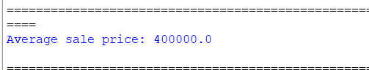
RESULT:
The average sale price of houses with more than four bedrooms was calculated successfully as 400000.0.

